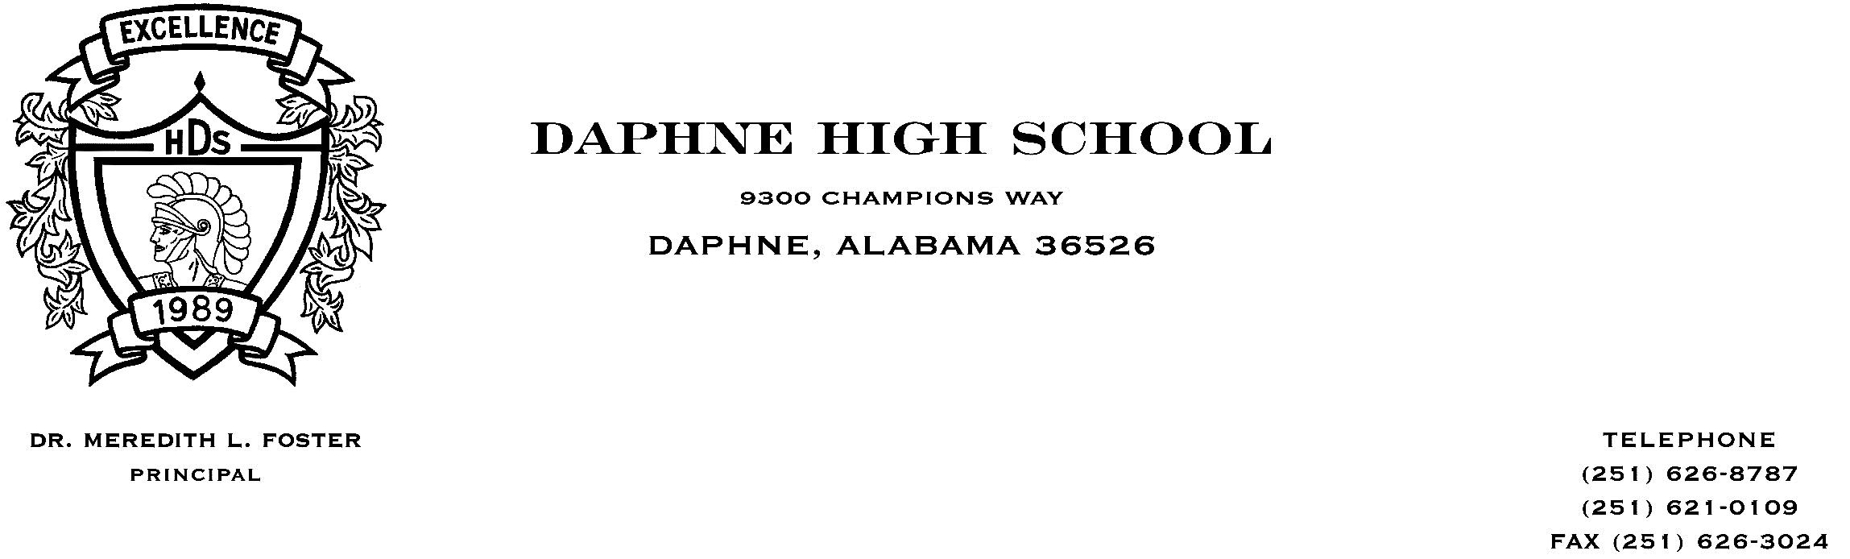April 5, 2018

Dear Parents,

In effort to better serve the academic needs of our students, we are expanding our course offerings for the 2018-2019 academic year to include the addition of honors level courses in both Social Studies and English Language Arts. This is due in large part to the restructuring of our Advanced Placement (AP) courses to include required readings throughout the entirety of the courses as well as the addition of a summer assignment.

The new honors level course progression has been created in hopes of targeting students that are seeking a more rigorous learning environment, but are apprehensive in making the commitment required of AP courses. Students should be aware that a CP with Distinction diploma requires the successful completion of AP coursework, which is not possible if opting to take honors level courses in lieu of AP. However, successful completion of honors level courses does increase the student’s overall weighted grade point average (GPA) by a half-point. AP courses offer a half-point GPA weight along with an additional half-point for taking the Advanced Placement College Board examination for that particular subject in May.

The following course progressions highlight the additional course offerings:

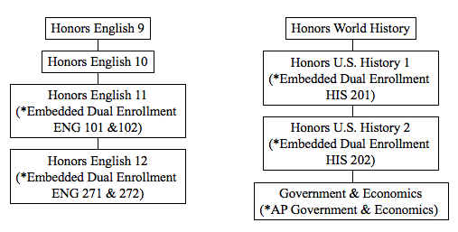

\*Optional Course Components

Recently, students were asked to submit desired course selections for next year; however, the decision to offer honors level courses in English and Social Studies had not been made at the time. Students wishing to change their course selections for next year will be provided a form to complete and submit indicating which courses they no longer wish to take as well as those courses they would like to add. Students and parents of students who are interested in enrolling in an honors level course should be mindful that the work required to be successful in the course will be more demanding than a standard course, but could ultimately be more rewarding and beneficial to the student in preparation for postsecondary coursework.

Feel free to contact your student’s respective grade level counselor should you have any questions, need additional information, and/or need further guidance.